PhD Position in Fundamental and Applied Chemistry of PN Cages
www.chitnislab.ca
Background: Our group explores geometrically interesting molecules for fundamental and functional chemistry. One area of focus is the development of scaffolds from which substituents can be reliably extended with well-defined bond angles and lengths. Such molecules have applications as connectors in materials chemistry, catalysis, and in the pharmaceutical industry due to their isosterism with bioactive motifs. While this parameter space is currently dominated by hydrocarbon frameworks (e.g. adamantanes, aryls), we are evolving phosphorus nitrogen (PN) cages as a new family of “molecular LEGO bricks” for constructing new classes of robust inorganic materials and molecules in a modular fashion (see references in figure below). The PN scaffolds we have developed are easy to synthesize and derivatize, offer a phosphorus NMR handle, are electron-pair rich, and fill a geometric gap between the traditional organic scaffold sizes currently available. In some cases, they also exhibit exceptional stability, setting the stage for applied chemistry.
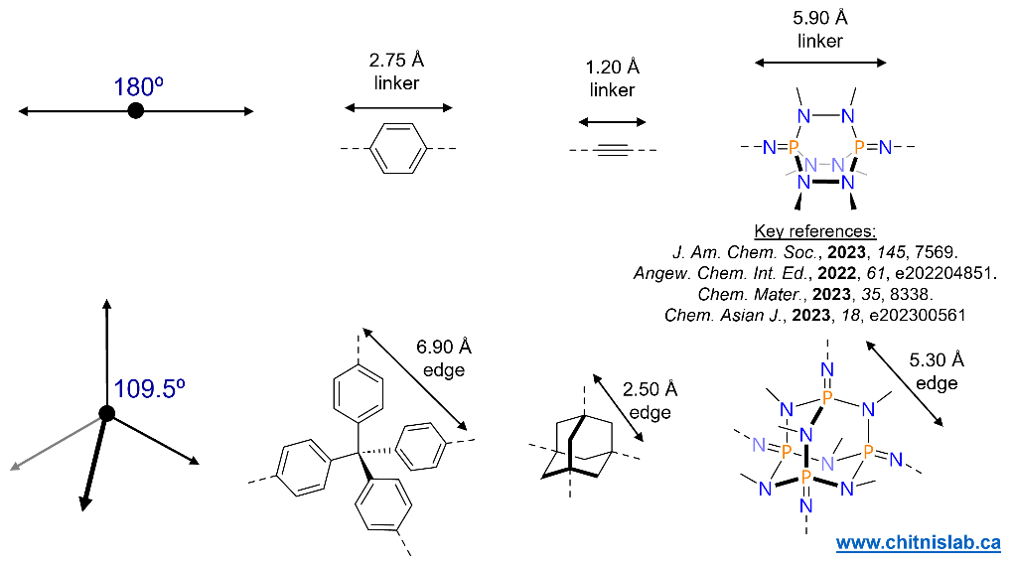
PhD Position: 1 PhD position is available for research advancing the chemistry of inorganic cages in fundamental and applied directions. In this position, you will work on discovering the fascinating fundamental chemistry of inorganic molecular cages and/or explore a bold new applied concept of using nitrogen-rich cages as fossil fuel-free monomers for clean, green future materials. You will develop synthetic inorganic/organometallic skills and gain experience in spectroscopic analysis across multiple length scales (molecular/macromolecular). You will use our state-of-the-art synthesis and characterization facilities, while working with collaborators to access a broad range of instrumentation and developing applications. As part of a medium-sized and diverse group with trainees at all levels, you will receive and offer 1:1 mentorship while participating in professional development courses to complement your technical training. Subject to availability of funds, you will present at (inter)national conferences.
Requirements: MSc or BSc (with research experience) in synthetic inorganic chemistry. Prior hands-on experience with Schlenk and/or glovebox chemistry will be an asset. Canadian citizenship or Permanent Resident status is not required. However, applicants without Canadian citizenship or Permanent Resident status must have completed a research-based MSc (with thesis).
Application: Please send your CV including academic history and research experience, and a list of publications (if any) by email to saurabh.chitnis@dal.ca with subject “PhD – Inorganic Cages”. Selected applicants will be contacted and invited to apply via the Faculty of Graduate Studies at Dalhousie University. A start date of May 1st, 2024 or September 1st, 2024 are preferred but later dates can also be accommodated.

